# ASIF AKHTAR

Mob: +917678195613

+91 8800967315 (WhatsApp)

email ID: [asifamu04@gmail.com](mailto:asifamu04@gmail.com)

Languages known: English, Hindi & Urdu

**CAREER OBJECTIVE** **:**

To use my knowledge and skills gained for betterment of the individual, firm and the society and take up the challenges and perform and translate my experience, knowledge, skills, and abilities into value for an organization.

* To build a long-term career in the field of Civil Engineering industry with opportunities for career growth.
* Seeking a responsible job with an opportunity for professional challenges.

# ACADEMIC QUALIFICATIONS:

|  |  |  |  |  |
| --- | --- | --- | --- | --- |
| **Degree/Course** | **Institute/College** | **University/Board** | **Percentage/**  **CGPA** | **Year of**  **passing** |
| **M.Tech**  **(Structural engineering)** | Galgotias University,  Gr. Noida | Galgotias University | 6.72 CGPA  (First Division) | 2018-2020 |
| **B.Tech**  **(Civil Engineering)** | Noida Institute of Engineering and  Technology, Gr.Noida | DR.A.P.J. ABDUL KALAM TECHNICAL UNIVERSITY,  LUCKNOW | 66% | 2013-2017 |
| **SSSC,12TH** | SNS COLLEGE | BSEB, PATNA | 77% | 2013 |
| **SSC(XTH)** | S.T.S HIGH SCHOOL | Aligarh Muslim University, Aligarh | 76% | 2009 |

# WORK EXPERIENCE:

# COMPANY : SUNTECH INFRA SOLUTIONS, L&T HYDROCARBON ENGINEERING

# HPCL-HRRL, BARMER, RAJASTHAN

**Designation** : **QA/QC Engineer**

**DURATION : JUNE 2021 to PRESENT**

**Job Responsibilities:**

* Execute and checking of pile work as per drawings and checking of all details of pile work at site
* All QA/QC works at plant and at site
* Testing of all incoming materials, fine aggregates, coarse aggregates and admixture
* Plant total production report and all concrete related work
* To check concrete work at site
* To check the quality related work of pile at site
* To conduct standard penetration test of soil and prepare reports
* Testing of cubes casted by CTM
* To carry PITS as per scope
* To Prepare load test reports conducted at site
* Prepare Pile Pour Cards and SPT Reports
* Prepare boring checklist and site and pile boring reports at site
* To work as batching plant Engineer.

# WORK EXPERIENCE:

# COMPANY : JAI BAGESHWARI CONSTRUCTION PVT. LTD

# VIVO INDUSTRIAL PROJECTS, GR. NOIDA

# DESIGNATION: SITE ENGINEER

**DURATION : APRIL 2021 to MAY 2021**

**Job Responsibilities:**

* Responsible for progress and monitoring of all civil works
* Execution of foundation work and superstructures as per specified drawings.
* Execute and monitor the ongoing construction work and analyze the final output.
* Discuss all work procedures with senior Engineers.
* Carry out all works as per IS CODES as per requirement.
* Checking of reinforcement as per drawing before casting for quality check
* Execute all work with safety at site
* Checking of form works
* Checking and reporting to site In charge after removal of form works with proper comments

# WORK EXPERIENCE:

# COMPANY : VICTOR CONSTRUCTIONS

**DESIGNATION : Site Engineer DURATION : Aug 2020 to March 2021**

**Job Responsibilities:**

* Discuss with Project In charge regarding related site work progress, drawings, sequence of works.
* Planning and monitoring of material requirement at site.
* Quality checking of all building materials and use them accordingly.
* Keep a close watch on the progress of project for timely completion.
* Established and implement work schedules and adjusted them to meet project deadlines.

# WORK EXPERIENCE:

**C0MPANY : SIMPLEX INFRASTRUCTURE, TOSHIBA JSW POWER SYSTEMS**

**PROJECT : HARDUAGANJ POWER PROJECT, ALIGARH DESIGNATION : QA/QC ENGINEER**

**DURATION : JULY 2017 – AUG 2018**

**Job Responsibilities:**

* Preparation of Project Quality Plan, Quality Control Procedures, QA procedures, Inspection Test Plans (ITP) for Civil activities and obtaining approval from Client.
* Implement the QA/QC management system at site.
* Coordinate with quality inspections with all the site sub-contractors and vendors coordinate all non-destructive testing on site.
* Maintain a daily record (daily diary) noting special comments. Reports to QA/QC Manager & Project Manager.
* Verify that the quality related site activities are in accordance with the applicable codes and standards.
* Coordinate with quality inspections with all the site sub-contractors and vendors coordinate all non-destructive testing on site.
* Worked as a batching plant engineer.

**KEY SKILLS:**

* Result oriented and Teamwork skills.
* Highly professional in time management, communicating information, analytical and problem

solving attitude.

* Proficient in planning and execution.
* Professionalism and strong work ethic.
* Computer Skills like AutoCAD, STAAD PRO, MS EXCEL, MS WORD
* Quality Standard Maintain
* Inspection Test Plan Maintain
* Quality Control Procedure
* Inspection
* Supplier Quality

**Testing Proficiency:**

Reinforcement - Tensile Strength, Elongation, Type of Bar, Diameter of Bar, Bar Bending as per BBS, Stirrups for Beam, Column, Roof Slab, Floor Slab, Spacing, Centre to Centre Line, Acceptance Criteria Concrete Cover for bottom of Reinforcement, Spacing for all side. Correct Way of Placing Reinforcement, Pre-Inspection, Follow up Engineering Rules & QC Procedure, Spacers Proper Tie Up with the Reinforcement.

**Concrete:**

Mix design, Trail Mix, Temperature, Slump, Cube making, Air content, Bleeding, Density, Compressive Strength (Cube, Cylinder/Core), and NDT tests.

**Aggregates:**

Grading, Material finer than 75microns, Abrasion Value, Impact, Flakiness, Elongation, Specific Gravity,

Density, Clay content

**Soil:**

Density moisture characteristics, Particle size distribution, liquid limit, plastic limit, Plasticity Index, Field

density by Nuclear Gauge and Sand cone Method, CBR, Plate load test, Zone Load for maximum Bearing

Capacity of Soil. Soil Improvement.

# PERSONAL DETAILS:

ADDRESS : HOUSE NO - 291, ABF PART 1, JAMIA NAGAR, OKHLA,

NEW DELHI-110025

D O B : 11/10/1993

NATIONALITY : INDIAN

# DECLARATION:

I hereby declare that all the information’s given are true to the best of my knowledge and understandings.

D**ate : Asif Akhtar**

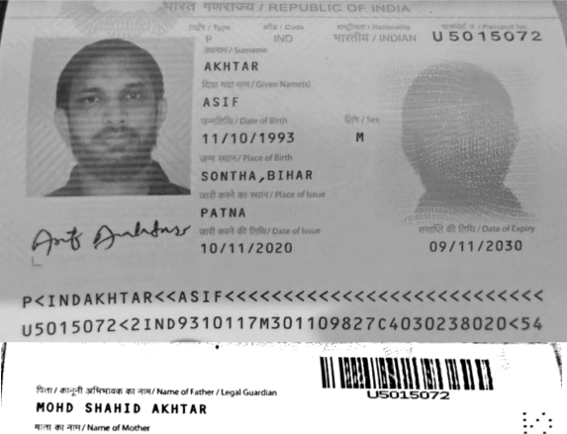

P E R ¥ A NT 0 L 7 S 0 NT fl A g' 0 NT H A K 15 h A NG A NJ







